LECTURE 13
MAIN MEMORY

Background – Main Memory
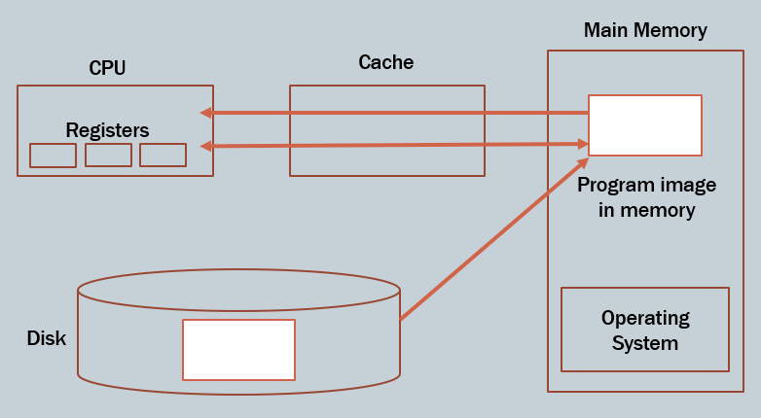
1. Basic Idea of the System
A computer system is made up of different memory and processing components that work together to execute programs efficiently.
The main components are:
- Disk (secondary storage)
- Main Memory (RAM)
- Cache
- CPU (with registers)
These components are organized based on speed and usage.
2. Memory Hierarchy (Order of Components)
The system follows a hierarchy from slowest to fastest:
- Disk (slowest, largest storage)
- Main Memory (faster, temporary storage)
- Cache (very fast, small)
- Registers (fastest, smallest, inside CPU)
As we move closer to the CPU:
- Speed increases
- Size decreases
3. Role of Each Component
Disk (Secondary Storage)
- Stores all programs and data permanently.
- Programs are initially saved here.
- It is very large but slow.
Main Memory (RAM)
- Programs must be loaded into RAM before execution.
- It stores:
  - Program currently running (program image)
  - Operating system
- It is faster than disk but slower than cache.
- It is volatile (data is lost when power is off).
Cache Memory
- Located between CPU and main memory.
- Stores frequently used data.
- Reduces the time to access memory.
CPU and Registers
- CPU executes instructions.
- Registers are inside CPU and store:
  - Current instruction
  - Temporary data
- Registers are the fastest memory but very limited.
4. Program Execution Flow
To run a program, the system follows these steps:
- The program is stored on the disk.
- It is loaded into main memory (RAM).
- The CPU fetches instructions from memory.
- Frequently used data is stored in cache.
- CPU uses registers to process instructions.
5. Data Access Flow (Important)
When CPU needs data, it checks in this order:
- Registers
- Cache
- Main Memory
- Disk (only if necessary)
This ensures faster execution by avoiding slow memory access whenever possible.
6. Role of Operating System
- The operating system is always present in main memory while the system runs.
- It manages:
  - Memory allocation
  - Process execution
  - Hardware communication
It acts as a controller between hardware and programs.

Main Memory and Disk storage
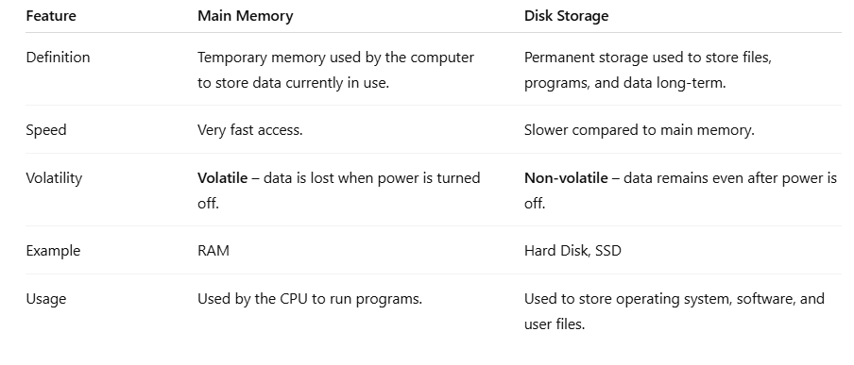

Program Addresses
1. Physical Addresses
Definition
- Physical addresses are the actual locations in RAM.
- These are the real addresses used by the memory hardware.
Example
- RAM locations: 0, 4, 8, 12, 16, …
If an instruction is at address 8, it means:
- It is stored at actual RAM location 8
2. Logical Addresses
Definition
- Logical addresses are the addresses generated by the CPU.
- A program uses these addresses while running.
Important Point
- A program does not know its real position in RAM
- It assumes it starts from address 0
Example
- Program uses:
  - 0 → first instruction
  - 4 → next
  - 8 → next
These are logical addresses, not real RAM locations.
3. Early Systems (No Relocation)
Key Idea
- Programs used physical addresses directly
What this means
- Logical address = Physical address
- No translation or mapping
How it worked
- If a program uses address 0, 4, 8:
  - It must be loaded exactly at:
    - RAM location 0, 4, 8
Problem
- No flexibility
  - Program must be loaded at fixed location
- No multiprogramming
  - Hard to run multiple programs together
- No protection
  - One program can overwrite another
- Wasted memory
  - Cannot adjust placement dynamically

Single Program (Using Physical Addresses)
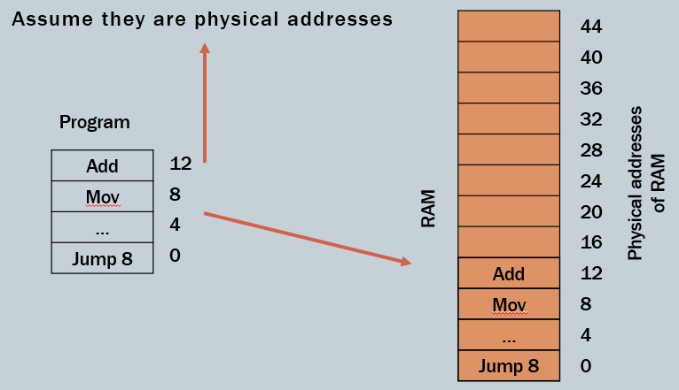
1. What is shown on the left (Program)
You see a program with instructions:
- Jump 8 → address 0
- … → address 4
- Mov → address 8
- Add → address 12
Meaning
- Each instruction has a fixed address
- These addresses are:
  - 0, 4, 8, 12
- These are assumed to be physical addresses
2. What is shown on the right (RAM)
- RAM is shown as a list of memory locations:
  - 0, 4, 8, 12, … up to 44
These are actual physical memory addresses
3. What the arrow shows
The arrow from program → RAM means:
- Instructions are placed exactly at the same addresses in RAM
4. Step-by-step placement
Instruction | Program Address | RAM Location
Jump 8 | 0 | 0
… | 4 | 4
Mov | 8 | 8
Add | 12 | 12
5. Important Observation
- There is no difference between:
  - Program addresses
  - Memory addresses
So:
Logical Address = Physical Address
6. Key Limitation
- Program must be loaded at exact location (starting at 0)
- If RAM is occupied → program cannot run
- Cannot move program anywhere else

Two Programs in Memory
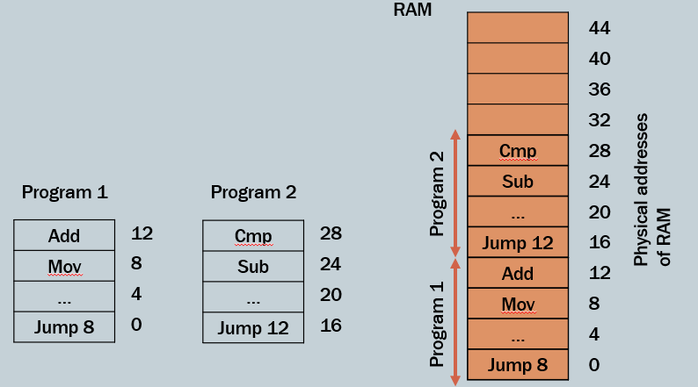
1. What is shown on the left
Two separate programs:
Program 1
- Addresses: 0, 4, 8, 12
- Instructions: Add, Mov, …, Jump 8
Program 2
- Addresses: 16, 20, 24, 28
- Instructions: Cmp, Sub, …, Jump 12
2. What is shown on the right (RAM)
RAM now contains both programs together:
Lower part:
- Program 1 at addresses:
  - 0, 4, 8, 12
Upper part:
- Program 2 at addresses:
  - 16, 20, 24, 28
3. What is actually happening
Each program is placed in a different region of memory
- Program 1 → lower memory
- Program 2 → higher memory
4. Critical Observation
Program 1
- Uses addresses: 0, 4, 8, 12
- Stored exactly at those locations → no issue
Program 2
- Its instructions appear at:
  - 16, 20, 24, 28 in RAM
BUT:
- Internally, program instructions still assume addresses like:
  - Jump 12
  - Sub at 24
5. The Core Problem
Program 2 is not starting at address 0 in RAM
- It is shifted upward (starts at 16)
But:
- Its instructions are written assuming fixed addresses
6. Why this is a problem
If Program 2 says:
- Jump 12
What does 12 mean?
- Does it mean:
  - Address 12 in RAM? (wrong location)
  - Or its own internal instruction?
This creates confusion and incorrect execution
7. Key Issue Identified by the Slide
- Programs cannot safely use direct physical addresses
- Because:
  - Memory location is not fixed
  - Programs may be placed anywhere
8. What this slide is teaching
This slide is showing the problem, not the solution.
It shows:
- When multiple programs exist:
  - Direct physical addressing fails

Logical Address Space Concept
1. Address Range
Each program uses a logical address range:
- From 0 → logical_max
Example:
- If program size = 16 bytes:
  - Logical addresses = 0 to 15
2. Physical Placement
- The same program can be placed anywhere in RAM
Example:
- It may be placed at:
  - Physical address 100 → 115
  - Or 500 → 515
3. Mapping Requirement
Since:
- Program uses logical addresses
- Memory uses physical addresses
We need a mapping mechanism
4. Mapping Mechanism (Important)
This is done using:
- Base register
  - Starting physical address of program
- Limit register
  - Size (range) of program
Formula
Physical Address = Logical Address + Base

Detailed Explanation of the picture
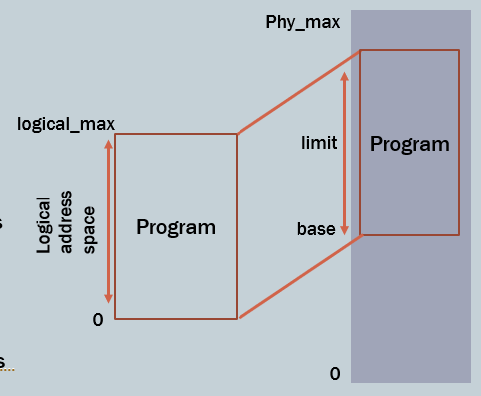
1. Left Side: Logical Address Space
- The left diagram shows the program’s view of memory
- It starts at:
  - Address 0
  - Ends at logical_max
Meaning
- The program assumes:
  - “I start at 0”
  - “My memory is continuous”
This is a virtual view, not real memory
2. Right Side: Physical Address Space (RAM)
- The right side shows actual RAM:
  - From 0 → phy_max
- The program is placed somewhere inside RAM (not at 0 necessarily)
3. Base and Limit (Very Important Part)
- The program occupies a portion of RAM defined by:
Base
- Starting physical address
- Example: 100
Limit
- Size of the program
- Example: 20
So program occupies:
- Physical addresses: 100 → 120
4. Mapping Process
The arrows show how logical addresses are converted:
Step-by-step:
- CPU generates logical address
  - Example: 5
- System checks:
  - Is it within limit?
    - 5 < limit → valid
- Add base:
  - Physical = base + logical
  - = 100 + 5 = 105
- Access memory location 105
5. Key Understanding
Separation of Views
- Program sees:
  - 0 → logical_max
- Memory sees:
  - base → base + limit
Flexibility
- Same program can run:
  - At 100 → 120
  - Or 500 → 520
Without changing program code
Protection
- Program cannot access:
  - Memory outside its limit
- Prevents:
  - Crashes
  - Interference with other programs

Binding of Instructions and Data to Memory
1. What is Address Binding?
Address binding means:
- Converting program addresses (logical) into actual memory addresses (physical)
This binding can happen at three different stages.
2. Types of Address Binding
A. Compile-Time Binding
Definition
- Binding is done before execution, during compilation.
How it works
- If the compiler knows the exact memory location where the program will be loaded:
  - It generates absolute addresses
Example
- Program is compiled assuming it will start at address 100
- Instruction:
  - Move → address 108 (fixed)
Limitation
- If memory location changes:
  - Program must be recompiled
Key Idea
- Logical address = Physical address
- No flexibility
B. Load-Time Binding
Definition
- Binding happens when the program is loaded into memory
How it works
- Compiler generates relocatable code
- Loader adjusts addresses based on where program is loaded
Example
- Program compiled with addresses starting at 0
- If loaded at 200:
  - Addresses are shifted by +200
Advantage
- More flexible than compile-time
Limitation
- Once loaded, program cannot move
C. Execution-Time Binding (Most Important)
Definition
- Binding is done during program execution
How it works
- Logical addresses are generated by CPU
- They are converted to physical addresses at runtime
Requirement
- Hardware support (MMU, base & limit registers)
Advantage
- Program can:
  - Move during execution
  - Be relocated dynamically
Key Idea
- Logical ≠ Physical
- Mapping happens dynamically
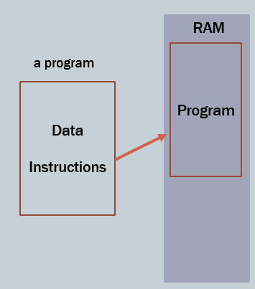
Explanation (Binding of Instructions and Data)
The slide shows that a program consists of instructions and data, which must be placed into RAM before execution. The arrows indicate that this placement (binding) can happen at different stages. The three bullet points explain that binding may occur during compile time (fixed addresses), load time (adjusted when loading), or execution time (dynamic mapping during runtime). The main idea is that execution-time binding is the most flexible because it allows programs to be moved in memory while running, using hardware support.

Base and Limit Registers
1. Concept
A pair of registers is used to:
- Define the logical address space of a program
- Protect memory access
2. Base Register
Definition
- Holds the starting physical address of the program in RAM
Example
- Base = 300040
- Means program starts at address 300040 in RAM
3. Limit Register
Definition
- Holds the size (range) of the program
Example
- Limit = 120900
- Program size = 120900 addresses
4. Address Translation Process
When CPU generates a logical address:
Step 1: Check validity
- Logical address < Limit
  - If false → error (illegal access)
Step 2: Convert address
- Physical Address = Base + Logical Address
5. Protection Mechanism
- Program cannot access:
  - Memory below base
  - Memory beyond base + limit
This prevents:
- Access to OS memory
- Access to other programs
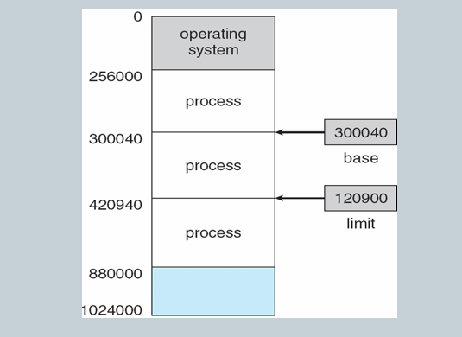
Explanation (Base and Limit Registers)
The slide shows a large memory (RAM) divided into sections, including the operating system and multiple processes. Each process occupies a specific region in memory. The base register points to the starting physical address of a process (shown as 300040), while the limit register defines the size of that process (120900).
This means the process can only access memory within the range:
- 300040 to (300040 + 120900)
When the CPU generates a logical address, it is checked against the limit. If valid, it is added to the base to get the actual physical address. This ensures that each process stays within its allocated memory and cannot interfere with other processes or the operating system.

Hardware Address Protection using Base and Limit Registers
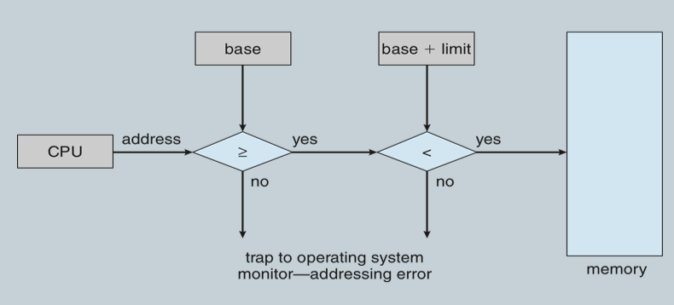
1. Diagram Explanation (Flow of Address Checking)
Step 1: CPU Generates Address
- CPU executes a program and requests a memory location
- Example: Address = 3500
Step 2: Base Register Check (Lower Bound)
Condition:
Address ≥ Base
- Base = starting address of the process
Meaning
- The program cannot access memory below its starting point
Cases
- If TRUE → go to next check
- If FALSE → trap to OS (error)
Step 3: Limit Register Check (Upper Bound)
Calculate
Upper Limit = Base + Limit
Condition:
Address < Base + Limit
Cases
- If TRUE → access allowed
- If FALSE → trap to OS (error)
Step 4: Final Decision
- If both checks pass → memory access allowed
- If any fails → OS interrupt (addressing error)
2. Base Register (Lower Bound)
Concept
- Base register stores the starting physical address of the process
Condition
Address ≥ Base
Meaning
- A process can only access memory starting from its base address
Example 1 (Valid Access)
- Base = 3000
- Address = 3500
Check:
- 3500 ≥ 3000 → TRUE
Result:
- Access allowed
Example 2 (Invalid Access)
- Address = 2500
Check:
- 2500 ≥ 3000 → FALSE
Result:
- Trap to OS (addressing error)
Key Insight
- Prevents access to:
  - OS memory
  - Memory of other processes below it
3. Limit Register (Upper Bound)
Concept
- Limit register stores the size of the process memory
Step 1: Calculate Maximum Address
Maximum Address = Base + Limit
Condition
Address < Base + Limit
Meaning
- A process cannot access memory beyond its allocated size
Example 1 (Valid Access)
- Base = 3000
- Limit = 1000
- Max Address = 4000
- Address = 3500
Check:
- 3500 < 4000 → TRUE
Result:
- Access allowed
Example 2 (Invalid Access)
- Address = 4200
Check:
- 4200 < 4000 → FALSE
Result:
- Trap to OS (addressing error)
Key Insight
- Prevents access to:
  - Memory of other processes above it
4. Combined Condition (Most Important)
A memory access is valid only if:
Base ≤ Address < Base + Limit
5. Combined Concept (Full Understanding)
How the System Works
- CPU generates a logical address
- Hardware checks:
  - Lower bound (base)
  - Upper bound (limit)
- If valid:
  - Address is used to access memory
- If invalid:
  - Trap is sent to OS
Why This is Needed
Without this mechanism:
- Programs could overwrite each other
- OS memory could be corrupted
- System would become unstable
What This Achieves
1. Memory Protection
- Each program stays within its own memory
2. Isolation
- Programs cannot interfere with each other
3. OS Safety
- OS memory remains protected

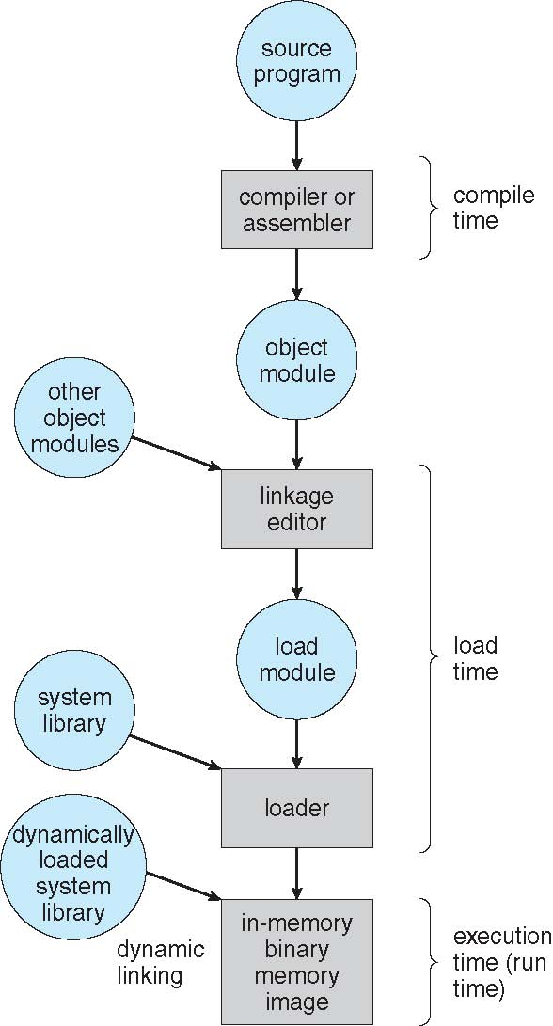
Multistep Processing of a User Program1. Overview
Before a program runs, it goes through multiple stages:
- Compile time
- Load time
- Execution time
Each stage transforms the program from source code → running program in memory
2. Diagram Explanation
Step 1: Source Program
- This is the original code written by the programmer
- Example:
  - C / C++ / Assembly code
Step 2: Compiler or Assembler (Compile Time)
- The source program is converted into: Object module
Output:
- Machine-level code (but not fully ready to run)
Step 3: Object Module
- Contains:
  - Compiled code
  - Unresolved references (e.g., functions not yet linked)
Step 4: Linking (Linkage Editor)
- Combines:
  - Object module
  - Other object modules
  - Required libraries
Input:
- Object module
- Other object modules
Output:
- Load module
Step 5: System Libraries
- Predefined functions (e.g., I/O, math functions)
- Used during linking or execution
Step 6: Load Module
- Fully prepared program
- Ready to be loaded into memory
Step 7: Loader (Load Time)
- Loads the program into RAM
- Allocates memory
Output:
- In-memory binary (program image)
Step 8: Dynamic Linking (Execution Time)
- Some libraries are loaded during execution
- Not all code is loaded at once
Example:
- A function is loaded only when called
Step 9: Execution (Run Time)
- Program runs in memory
- CPU starts executing instructions

Logical vs Physical Address Space
1. Core Concept
- In modern systems:
  - Logical address space and physical address space are separate
- This separation is essential for proper memory management
2. Logical Address
Definition
- Logical address is the address generated by the CPU
Other Name
- Also called virtual address
Key Points
- Used by the program
- Starts from 0
- Program thinks it is using full memory
- Not the real RAM address
3. Physical Address
Definition
- Physical address is the actual address in RAM
Key Points
- Used by memory hardware
- Real location where data is stored
- Managed by OS
4. Address Spaces
Logical Address Space
- Set of all logical addresses generated by a program
- Example:
  - 0 → logical_max
Physical Address Space
- Set of all actual memory addresses in RAM
- Example:
  - 0 → phy_max
5. Relation Between Logical and Physical Addresses
Case 1: Compile-Time Binding
- Logical = Physical
- No difference
Case 2: Load-Time Binding
- Logical = Physical (after loading)
- Fixed after placement
Case 3: Execution-Time Binding (Important)
- Logical ≠ Physical
- Mapping is done during execution
6. Why Logical and Physical are Different
- Programs should run:
  - Anywhere in memory
  - Without modification
- System needs:
  - Flexibility
  - Protection
  - Multiprogramming
Explanation
Modern operating systems separate logical and physical address spaces to manage memory efficiently. The logical address is generated by the CPU during program execution and represents the program’s view of memory. In contrast, the physical address is the actual location in RAM where data is stored and accessed by the memory hardware.
In earlier or simpler binding methods such as compile-time and load-time binding, logical and physical addresses are the same because the program is placed at a fixed memory location. However, in execution-time binding, which is used in modern systems, logical and physical addresses are different. In this case, the system dynamically maps logical addresses to physical addresses during program execution.
Logical address space is the complete set of logical addresses generated by a program, and physical address space is the set of actual memory addresses used in RAM. This separation allows programs to run independently of their physical location in memory, enabling better flexibility, protection, and efficient memory usage.

Memory Management Unit (MMU)
1. Definition
- MMU is a hardware device
- It performs:
  - Mapping of logical (virtual) addresses → physical addresses
- This happens at run time (execution time)
2. Key Idea
- CPU generates logical addresses
- Memory uses physical addresses
- MMU converts between them
3. How It Works
- When CPU generates an address:
  - It is sent to MMU
- MMU converts it using:
  - Relocation register (base register)
4. Relocation Register
- Stores the starting physical address of the program
- Also called base register

Dynamic Relocation using Relocation Register
1. Concept
- Dynamic relocation means:
  - Address translation happens during execution
- Logical address is converted to physical using:
Formula
Physical Address = Logical Address + Base
2. Diagram Explanation (Step-by-Step)
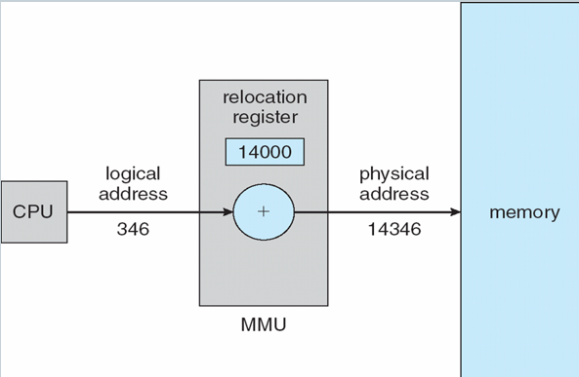
Step 1: CPU Generates Logical Address
- Example:
  - Logical Address = 346
Step 2: Relocation Register (Base)
- Base = 14000
Step 3: MMU Performs Addition
Physical Address = 346 + 14000 = 14346
Step 4: Access Memory
- Memory location 14346 is accessed
3. Key Understanding
- Program thinks:
  - It is using address 346
- Actually:
  - It is accessing 14346 in RAM
4. Advantages
- Program can be loaded anywhere
- No need to modify program code
- Supports multiprogramming

Dynamic Linking
1. Static Linking
Definition
- All libraries are combined with program before execution
Result
- Large program size
- Libraries are fixed
2. Dynamic Linking (Important)
Definition
- Linking is done during execution
3. How Dynamic Linking Works
Step 1: Stub Code
- A small piece of code is placed instead of actual function
Step 2: Function Call
- When function is needed:
  - Stub checks if it is already in memory
Step 3: OS Check
- If function exists:
  - Use it directly
- If not:
  - Load it into memory
Step 4: Execution
- Stub replaces itself with actual function address
- Function is executed

Swapping
Definition
- Swapping is a technique in which a process is temporarily moved from main memory to a backing store (disk).
- The process is later brought back into memory to continue execution.
Key Idea
- The total memory required by all processes can be greater than physical memory.
- Swapping allows the OS to manage this excess demand.
Backing Store
- A fast disk used to store swapped processes.
- Characteristics:
  - Must be large enough to store all processes
  - Must support direct access to memory images
Roll Out / Roll In
- Used in priority-based scheduling:
  - Roll out → Lower-priority process is swapped out
  - Roll in → Higher-priority process is brought into memory
- Ensures high-priority processes execute first
Swapping Time
- Major portion of swap time = data transfer time
- Important point:
  - Total transfer time ∝ size of process memory
- Larger processes → more swapping time
Ready Queue Concept
- OS maintains a ready queue of processes ready to execute
- Some processes:
  - Are in main memory
  - Others are in backing store (disk) waiting to be swapped in

Schematic View of Swapping
Structure of System
- Main memory contains:
  - Operating System
  - User processes
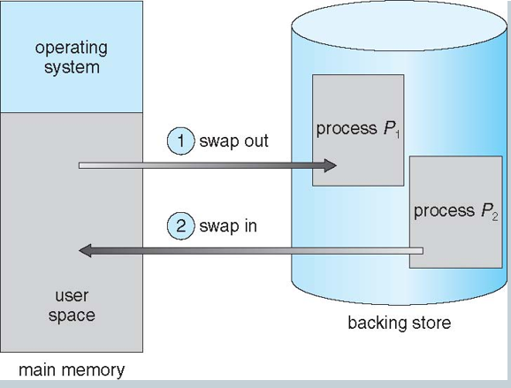
- Backing store (disk) contains:
  - Swapped-out processes
Working (Step-by-Step Flow)
- Process P1 is in main memory
- Memory needs to be freed (or another process is needed)
- Swap Out:
  - P1 is moved from memory → backing store
- Swap In:
  - Another process (P2) is brought from disk → memory
- CPU starts executing P2
Important Observations
- Only some processes stay in memory at a time
- Others remain on disk until needed
- OS continuously manages:
  - Which process to remove
  - Which process to bring in

Context Switch Time Including Swapping
Basic Idea
- If the next process to run is not in memory:
  - OS must:
    - Swap out a current process
    - Swap in the required process
Effect on Context Switching
- Context switching becomes very slow
- Reason:
  - Disk operations are much slower than memory operations
Example Calculation
Given:
- Process size = 100 MB
- Disk transfer rate = 20 MB/sec
- Disk latency = 8 ms
Swap Out Time:
- Transfer time = 100 / 20 = 5 sec

  - latency = 5.008 sec
Swap In Time:
- Same = 5.008 sec
Total Swapping Time:
- Total = 5.008 + 5.008
- ≈ 10.016 sec
Slide Approximation:
- Swap out = 2008 ms
- Swap in = 2008 ms
- Total = 4016 ms (~4 sec)

Contiguous Allocation
Definition
- Contiguous allocation is a memory management technique where:
  - Each process is stored in one continuous (adjacent) block of memory.
- Entire program occupies consecutive memory locations.
Memory Structure
- Main memory is divided into two parts:
  - Operating System (OS)
    - Stored in low memory
    - Remains permanently in memory (Resident OS)
  - User Processes
    - Stored in high memory
Resident Operating System
- OS stays permanently in RAM during execution.
- Responsibilities:
  - Controls hardware
  - Manages processes
  - Provides system services
Key Features
- Each process is allocated:
  - A single contiguous block
- Memory access is:
  - Simple and fast
- But can lead to:
  - Fragmentation (wasted space)
Multiple-Partition Allocation
- Memory divided into multiple partitions (chunks)
Important Points:
- Chunk = block of available memory
- Chunks can be of different sizes
- When a process arrives:
  - It is allocated a chunk large enough
OS Responsibilities
- Keeps track of:
  - Allocated partitions
  - Free partitions (holes/chunks)
Limitation
- Degree of multiprogramming depends on:
  - Number of partitions available

Address Translation & Protection
Need
- Prevent processes from:
  - Accessing each other's memory
  - Modifying OS memory
Relocation Register (Base Register)
- Stores:
  - Starting physical address of a process
- Used to:
  - Convert logical → physical address
Limit Register
- Stores:
  - Maximum size (range) of process memory
- Ensures:
  - Process does not access memory beyond its limit
Address Translation Rule
- Logical address must satisfy:
  - Logical Address < Limit Register
- If valid:
  - Physical Address = Base + Logical Address
- If invalid:
  - Trap (error) occurs
Role of MMU (Memory Management Unit)
- Performs:
  - Dynamic address mapping
- Converts logical addresses to physical addresses at runtime

Diagram Explanation (Hardware Support)
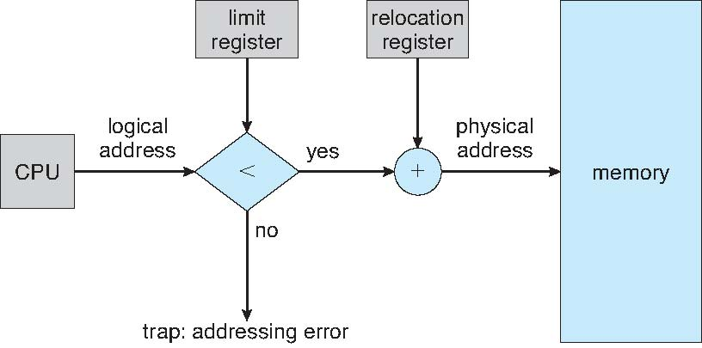
Step-by-Step Flow
- CPU generates a logical address
- This address is checked:
  - Compared with limit register
Case 1: Valid Address
- If:
  - Logical Address < Limit
- Then:
  - Address is valid
  - MMU adds:
    - Relocation Register (Base)
- Result:
  - Physical Address = Base + Logical Address
- Process accesses memory successfully
Case 2: Invalid Address
- If:
  - Logical Address ≥ Limit
- Then:
  - Address is invalid
- Result:
  - Trap (addressing error) is generated
Key Insight from Diagram
- Limit register = protection
- Relocation register = address translation
- Together they ensure:
  - Safe and correct memory access

Problem (Contiguous Allocation Issue)
Step-by-Step What is Happening
Initial State
- Memory contains:
  - OS
  - Process 5
  - Process 8
  - Process 2
Step 1: Process 8 Leaves
- Process 8 is removed
- A free space (hole) is created in the middle
Step 2: Process 9 Arrives
- Process 9 is allocated in that free space
- But:
  - It does not fully occupy the hole
- So a small leftover free space remains
Step 3: Process 10 Arrives
- Process 10 is placed into the remaining space
Core Problem Identified
1. Hole Creation
- When processes leave → holes (free chunks) are created
2. Unequal Free Spaces
- Holes are:
  - Of different sizes
  - Scattered across memory
3. External Fragmentation
- Memory becomes:
  - Fragmented into small pieces
- Even if total memory is enough:
  - A process may not fit into any single hole

Solution (Dynamic Storage Allocation)
To solve the above problem, OS uses allocation strategies:
1. First Fit
- Allocate the first hole that is large enough
Working:
- Scan memory from start
- Stop at first suitable hole
Pros:
- Fast
- Simple
Cons:
- Leaves many small holes at beginning
2. Best Fit
- Allocate the smallest hole that is sufficient
Working:
- Search entire memory
- Choose closest-fit hole
Pros:
- Minimum leftover space
Cons:
- Slow (full search needed)
- Creates many tiny unusable holes
3. Worst Fit
- Allocate the largest available hole
Working:
- Search entire memory
- Pick biggest hole
Pros:
- Leaves large free spaces
Cons:
- Wastes large blocks
- Not efficient overall

Fragmentation (Memory Management)
1. Definition
- Fragmentation is a memory management problem where:
  - Free memory is broken into small unused pieces
  - This makes efficient allocation difficult
2. Types of Fragmentation
1. Internal Fragmentation
- Occurs when:
  - Allocated memory block is larger than requested
- The extra space:
  - Remains unused inside the allocated block
Key Point:
- Wasted memory is inside the partition
2. External Fragmentation
- Occurs when:
  - Free memory is available but scattered
  - Not in one continuous block
Key Point:
- Total memory may be enough, but:
  - It is not contiguous, so large process cannot be allocated
3. Problem Summary
Type | Issue Location | Cause
Internal Fragmentation | Inside allocated block | Fixed/oversized allocation
External Fragmentation | Outside (free space) | Scattered holes
4. Solution to External Fragmentation
Compaction
- Technique used to reduce external fragmentation
5. Compaction
Definition
- Compaction is the process of:
  - Rearranging memory contents
  - So that all free memory is combined into one large block
Working
- OS:
  - Shifts processes in memory
  - Collects all free spaces together
Result
- Many small holes → one large contiguous free block
6. Conditions for Compaction
- Compaction is possible only if:
  - Relocation is dynamic
  - Done during execution time
7. Issues with Compaction
I/O Problem
- While a process is performing I/O:
  - It cannot be moved easily
Solutions:
- Latch (lock) the process in memory during I/O
- Perform I/O only into:
  - OS buffers instead of process memory

